- Kumpulan screenshot hasil dari run flutter

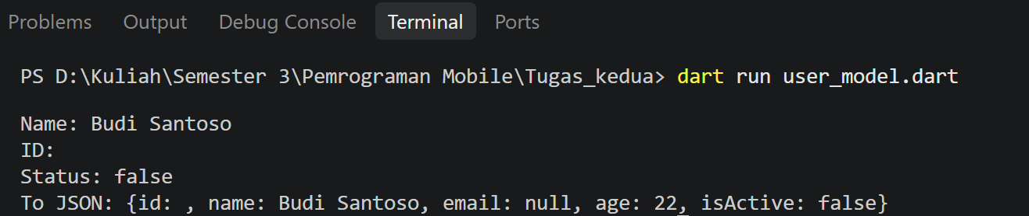

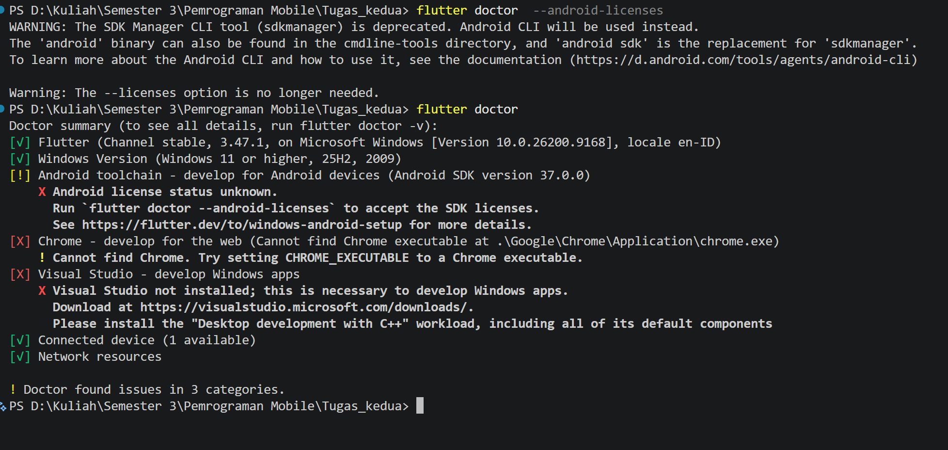
- Update/ push commit code github repository Mobile

https://github.com/hakuyha/Pemrograman-Mobile/tree/master/Tugas_kedua

